EXP 15 : SIMULATION OF CONVOLUTIONAL CODES AND ANALYSIS OF ENCODED OUTPUT BIT SEQUENCES USING MATLAB

SOFTWARE USED : MATLAB SOFTWARE

CODE :
clc; clear; close all

bits = [1 0 1 1 0 1 0 0 1 1];
trellis = poly2trellis(3,[7 5]);
encoded = convenc(bits,trellis);

subplot(2,1,1)
stairs(bits,'b','LineWidth',1.5), grid on
title('Input Binary Sequence')
ylim([-0.2 1.2])

subplot(2,1,2)
stairs(encoded,'r','LineWidth',1.5), grid on
title('Convolutionally Encoded Output')
ylim([-0.2 1.2])

disp('Encoded Output Bits:')
disp(encoded)

MODEL GRAPH :
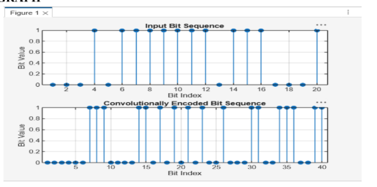

RESULT :
